**[Riemannian TransE: Multi-relational Graph Embedding in Non-Euclidean Space](https://openreview.net/forum?id=r1xRW3A9YX)**

[Atsushi Suzuki](https://openreview.net/profile?email=atsushi-suzuki%40g.ecc.u-tokyo.ac.jp), [Yosuke Enokida](https://openreview.net/profile?email=xenolay%40g.ecc.u-tokyo.ac.jp), [Kenji Yamanishi](https://openreview.net/profile?email=yamanishi%40mist.i.u-tokyo.ac.jp)

‎28‎ ‎Sep‎ ‎2018 (modified: ‎21‎ ‎Dec‎ ‎2018) ICLR 2019 Conference Blind Submission Readers: Everyone 11 Replies

[Hide details](https://openreview.net/group?id=ICLR.cc/2019/Conference#r1xRW3A9YX-details-577)

* **Abstract:** Multi-relational graph embedding which aims at achieving effective representations with reduced low-dimensional parameters, has been widely used in knowledge base completion. Although knowledge base data usually contains tree-like or cyclic structure, none of existing approaches can embed these data into a compatible space that in line with the structure. To overcome this problem, a novel framework, called Riemannian TransE, is proposed in this paper to embed the entities in a Riemannian manifold. Riemannian TransE models each relation as a move to a point and defines specific novel distance dissimilarity for each relation, so that all the relations are naturally embedded in correspondence to the structure of data. Experiments on several knowledge base completion tasks have shown that, based on an appropriate choice of manifold, Riemannian TransE achieves good performance even with a significantly reduced parameters.
* **Keywords:** Riemannian TransE, graph embedding, multi-relational graph, Riemannian manifold, TransE, hyperbolic space, sphere, knowledge base
* **TL;DR:** Multi-relational graph embedding with Riemannian manifolds and TransE-like loss function.

Multi-relational graph embedding which aims at achieving effective representations with reduced low-dimensional parameters, has been widely used in knowledge base completion. Although knowledge base data usually contains tree-like or cyclic structure, none of existing approaches can embed these data into a compatible space that in line with the structure. To overcome this problem, a novel framework, called

问题描述 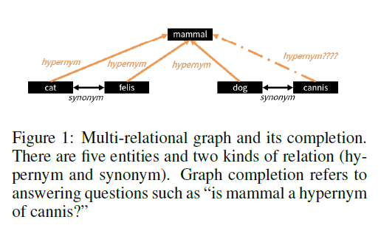

Riemannian TransE, , embed the entities in a Riemannian manifold

1. each relation as a move to a point and defines specific

基本模型

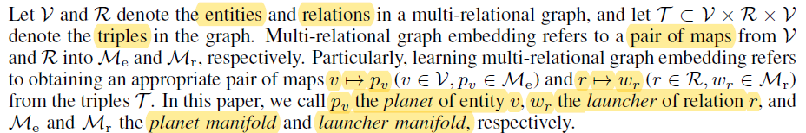

2）novel distance dissimilarity for each relation

优化目标：从 f 到 扩展 f，其中 D 为 dissimilarity

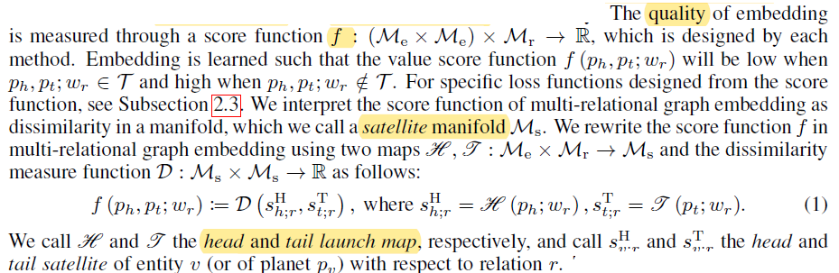

3）扩展 Transe 到 Riemannian 空间

学习模型

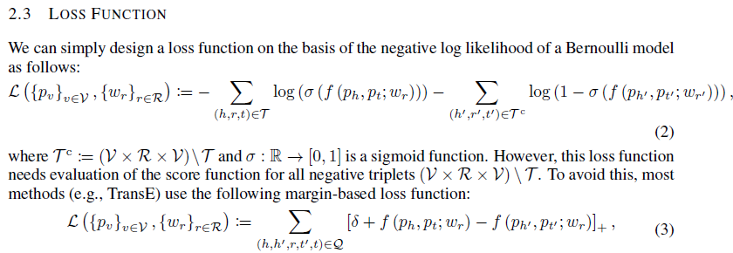

通过增强wr 和 lr （高亮部分）实现扩展

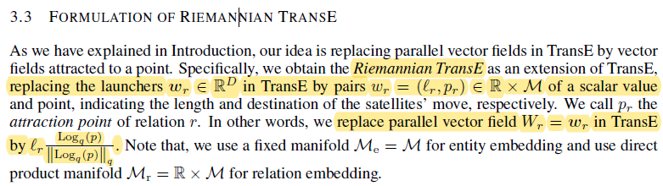

示例

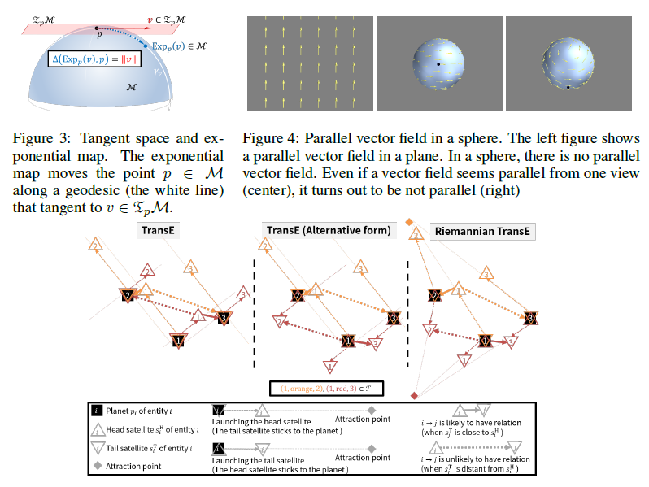

Figure 5: Difference between TransE and Riemannian TransE.

In these examples, the number jVj of entities is three (1, 2, 3) and the number jRj of relations is two (red and orange), with triples (1, orange, 2) and (1, red, 3). Hence, these models learn that the orange head satellite of Entity 1 is close to the orange tail satellite of Entity 2 and the red head satellite of Entity 1 is close to the red tail satellite of Entity 3. In addition, the distance of the other pair of satellites should be long in the representation learned by each method. The figure on the left shows the original formulation of TransE, where the satellites are given by vector addition. In other words, the satellites are given by a move towards a point at infinity from the planet. The center figure shows an alternative formulation of TransE, which is equivalent to the original TransE. Here, the tail satellites are launched and the head satellites are fixed in the red relation. In Riemannian TransE in the figure on the right, the vector additions are replaced by a move towards a (finite) point.

all the relations are naturally embedded in correspondence to the structure of data.

Experiments on several knowledge base completion tasks have shown that, based on an appropriate choice of manifold, Riemannian TransE achieves good performance even with a significantly reduced parameters.